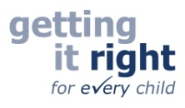

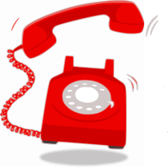

The Children and Young People’s Physiotherapy service works across Edinburgh, East and Mid Lothian, and the Royal Hospital for Children and Young People.
Please visit the leaflet section of our website which provides information/advice on a range of common conditions and queries often referred to Paediatric Physiotherapists.
https://children.nhslothian.scot/departments_services/physiotherapy

Still concerned?

We run telephone help lines to answer queries you may have about your child or young person. This service can be accessed by health/education professionals and parents/ carers to discuss any concerns or seek advice using the numbers below.

For concerns regarding a child’s motor skills or development:
Edinburgh: 0131 312 2347

East Lothian and Midlothian: 0131 446 4144
Thursday mornings from 9.00 to 11.00

For concerns about bone, joint or muscle pain:
Edinburgh, East and Mid Lothian Paediatric Physiotherapy Musculoskeletal Team Self Referrals: 0131 312 1079

